CSE 590 Final Project Report

Parallel GPU based Implementations of K-means Clustering

Aadarsh Jajodia, Akshit Poddar, Shahzeb Patel

**Aim:** Implementation of parallel k-means clustering algorithm on CUDA and OpenCL and do their comparison with the sequential approach to analyze the speedup achieved

**Summary** — The k-means algorithm is widely used for unsupervised clustering. Our project describes an efficient parallel k-means algorithm. Different from existing GPU-based k-means algorithms, and we have used the algorithm implemented in -<http://www.knowcenter.tugraz.at/download_extern/papers/latex8.pdf>. Emphasis is placed on optimizations directly targeted at this architecture to best exploit the computational capabilities available. The algorithm is realized in a hybrid manner, parallelizing distance calculations on the GPU while sequentially updating cluster centroids on the CPU based on the results from the GPU calculations. We have also made use of other parallel k-means clustering algorithms papers and referenced them and have referenced them below. Section 4 highlights the results of our empirical evaluations of CUDA and OpenCL implementations against sequential implementations.

**Note:** Most of the content of the literature in this report is credited towards the main paper that we have used and the reference papers mentioned in the end. We have presented the matter here inorder to present a holistic view of the report. Our main aim has been the implementation of the approach in the paper mentioned above in CUDA and OpenCL, and compare them against sequential approach.

1. **Background**

Clustering is a method of unsupervised learning that partitions a set of data objects into clusters, such that intra-cluster similarity is maximized while inter-cluster similarity is minimized. The k-Means algorithm is one of the most popular clustering algorithms and is widely used in a variety of fields such as statistical data analysis, pattern recognition, image analysis and bioinformatics. It has been elected as one of the Top 10 data mining algorithms. The running time of k-means algorithm grows with the increase of the size and also the dimensionality of the data set. Hence clustering large-scale data sets is usually a time-consuming task. Parallelizing k-Means is a promising approach to overcoming the challenge of the 3 huge computational requirement. In P-CLUSTER has been designed for a cluster of computers with a client-server model in which a server process partitions data into blocks and sends the initial centroid list and blocks to each client. It has been further enhanced by pruning as much computation as possible while preserving the clustering quality. In the k-means clustering algorithm has been parallelized by exploiting the inherent data-parallelism and utilizing message passing.

With the appearance of programmable graphics hardware in 2001, using the GPU as a low-cost highly parallel streaming co-processor became a valuable option. In the following years scientific interest in this new architecture resulted in numerous publications demonstrating the advantages of GPUs over CPUs when used for data parallel tasks. Much attention was focused on transferring common parallel processing primitives to the GPU and creating frameworks to allow for more general purpose programming. The most problematic aspect of this undertakings was transforming the problems at hand into a graphics pipeline friendly format, a task needing knowledge about graphics programming. The reader shall be referred to where an in-depth discussion on mapping computational concepts to the GPU can be found. This entry barrier was recently lowered by the introduction of NVIDIA’s CUDA as well as ATI’s Close to Metal Initiative. Both were designed to enable direct exploitation of the hardware’s capabilities circumnavigating the invocation of the graphics pipeline via an API such as OpenGL or DirectX. In this work CUDA was chosen due to its more favorable properties, namely the high-level approach employed by its seamless integration with C and the quality of its documentation.

1. **Related Work**

To the best of the authors’ knowledge, three different implementations of k-means on the GPU exist. All three implementations are similar to the parallel k-means implementation outlined in section 3.3 formulated as a graphics programming problem. In Takizawa and Kobayashi try to overcome the limitations imposed by the maximum texture size by splitting the data set and distributing it to several systems each housing a GPU. A solution to this problem via a multi-pass mechanism was not considered. Also the limitation on the maximum number of dimensions was not tackled. It is also not stated whether the GPU implementation produces the same results as the CPU implementation in terms of precision. Hall and Hart propose two theoretical options for solving the problem of limited instance counts and dimensionality: multi-pass labeling and a different data layout within the texture. None of the approaches have been implemented though. In addition to the naive k-means implementation the data is reordered to minimize the number of distance calculations by only calculating the metrics to the nearest centroids. This is achieved by finding those centroids by traversing a previously constructed kd-tree.

The authors could not observe any problems caused by the non standard compliant floating point arithmetic implementations on the GPU, stating that the exact same clusterings have been found. The approach differs in that the centroid indices are stored in an 8-bit stencil buffer instead of the frame buffer limiting the number of total centroids to 256. Limitations in dimensionality and instance counts due to maximum texture sizes are solved via a costly multi-pass approach. No statements concerning precision of the GPU version were made. Summarizing the presented previous work the following can be observed: All implementations suffer from architectural constraints such as maximum texture size limiting the number of instances, dimensions and clusters. The limitations can only be overcome by employing more costly multi-pass approaches.

Not all referened papers state the exact conditions the implementations were tested under. A direct comparison is not strictly possible. However, the given numbers indicate congruent results yielding an average speedup of a factor between 3 to 4. The GPU implementation’s performance increases as the problem at hand grows bigger in dimensionality as well as instance and centroid count. • Only one paper mentioned potential impact of the non-standard-compliant floating point arithmetics implemented on GPU’s. No effects have been observed.

# **K-means Clustering[1]**

## Algorithm

K-Means is a commonly used clustering algorithm used for data mining. Clustering is a means of arranging n data points into k clusters where each cluster has maximal similarity as defined by an objective function. Each point may only belong to one cluster, and the union of all clusters contains all n points. We describe Lloyd’s fast algorithm for computing an approximate solution to the K-means problem. The algorithm assigns each point to the cluster whose center (also called centroid) is nearest. The center is the average of all the points in the cluster that is, its coordinates are the arithmetic mean for each dimension separately over all the points in the cluster. The algorithm steps are:

1) Choose the number of clusters, k.

2) Randomly generate k clusters and determine the cluster centers, or directly generate k random points as cluster centers.

3) Assign each point to the nearest cluster center.

4) Re-compute the new cluster centers.

5) Repeat the two previous steps until some convergence criterion is met (usually that the assignment hasn’t changed).

The main disadvantage of this algorithm is that it does not yield the same result with each run, since the resulting clusters depend on the initial random assignments. It minimizes intra-cluster variance, but does not ensure that the result has a global minimum of variance [5]. If, however, the initial cluster assignments are heuristically chosen to be around the final point, one can expect convergence to the correct values. proposes an optimization by choosing initial centroids close to existing clusters. The first and second phases of the algorithm take Θ(k) time, while the third phase takes Θ(nk) to complete. Finally, the fourth phase’s execution time is in the order of Θ(n + k). In a typical application n>k, therefore the execution time of the algorithm is bound by the third phase. This observation directed us to concentrate our efforts on parallelizing the third phase of the k-means algorithm.

## Parallel K-means clustering

Parallel K-Means: In a parallel implementation of kmeans on distributed memory multiprocessors. The labeling stage is identified as being inherently data parallel. The set of data points X is split up equally among p processors, each calculating the labels of all data points of their subset of X . In a reduction step the centroids are then updated accordingly. It has been shown that the relative speedup compared to a sequential implementation of k-means increases nearly linearly with the number of processors. Performance penalties introduced by communication cost between the processors in the reduction step can be neglected for large n.

**Algorithm : Parallel K-Means Algorithm**

*if threadId = 0 then*

*cj ← random xi ∈ X , j = 1, . . . , k, s.t. cj != ci*

*end if*

*synchronize threads*

*repeat*

*for all xi ∈ XthreadId do*

*li ← arg minD(cj , xi)*

*end for*

*synchronize threads*

*if threadId=0 then*

*for all xi ∈ X do*

*cli ← cli + xi*

*mli ← mli + 1*

*end for*

*for all cj ∈ C do*

*cj ← (1 / mj) ci*

*end for*

*if convergence then*

*signal threads to terminate*

*end if*

*end if*

*until convergence*

1. **Experimental Evaluation**

We divide the evaluation in two parts. First we compare the implementation with CUDA with the sequential implementation on CPU. The input is varied for dimensions of 2, 20, 200 and of input size 5000, 50000, 100000. For all such input sizes, the number of cluster varies from 2 to 128 with incremental powers of 2.

The input provided to the parallel algorithm is multi dimensional points with dimensions represented as Single-precision floating-point.

eg: Following are 5 points with 10 dimensions

1 1.138306 -1.215842 0.555809 1.026545 -2.430758 4.322971 -1.217299 -2.184030 -1.388817 0.166098

2 -2.876999 -4.873641 1.715104 4.581660 4.803759 0.744806 2.249417 1.776730 1.125599 -3.469210

3 -2.077210 1.499280 -4.915942 -2.140810 3.764414 -0.272780 -4.171116 0.006001 -1.817014 -0.969820

4 -3.276886 4.321291 2.814338 2.278923 0.347836 -4.616421 1.601894 4.130538 -1.800450 -4.786923

5 -0.703364 0.322551 -4.660563 -3.988260 -0.095789 -4.856805 1.756546 -2.846372 1.919924 -2.117855

The source code tarball also contains program to generate input based on given

First we compare the sequential run time with the CUDA parallel implementation. The number of vertices are 5000, 50000, 10000 and dimensions are of 2, 20, 200. The number of cluster range from 2 to 128 with increasing power of 2. The results are as follows.

**CUDA Results**

1. Run time 5000 nodes:

|  |  |  |  |  |  |  |
| --- | --- | --- | --- | --- | --- | --- |
| Number of Clusters | CPU(Dim = 2) | GPU(Dim = 2) | CPU(Dim = 20) | GPU(Dim = 20) | CPU(Dim = 200) | GPU(Dim = 200) |
| 2 | 0.0047 | 1.6138 | 0.0656 | 1.6509 | 0.451 | 2.1453 |
| 4 | 0.0077 | 1.3333 | 0.2416 | 1.393 | 0.6237 | 1.5667 |
| 8 | 0.0381 | 1.3371 | 0.3155 | 1.3711 | 1.4002 | 1.5821 |
| 16 | 0.1069 | 1.3358 | 0.5893 | 1.3953 | 1.8373 | 1.5419 |
| 32 | 0.1439 | 1.332 | 1.3473 | 1.3642 | 3.4217 | 1.5158 |
| 64 | 0.4177 | 1.3384 | 1.0732 | 1.3716 | 4.2123 | 1.5576 |
| 128 | 0.2607 | 1.3402 | 1.7357 | 1.3633 | 6.1313 | 1.6059 |

Speedup:

|  |  |  |  |
| --- | --- | --- | --- |
| Number of Clusters | Dim = 2 | Dim = 20 | Dim = 200 |
| 2 | 0.002912380716 | 0.03973590163 | 0.2102270079 |
| 4 | 0.005775144379 | 0.1734386217 | 0.3980979128 |
| 8 | 0.02849450303 | 0.2301072132 | 0.885026231 |
| 16 | 0.08002695014 | 0.4223464488 | 1.191581815 |
| 32 | 0.108033033 | 0.9876117871 | 2.257355852 |
| 64 | 0.3120890616 | 0.7824438612 | 2.704352851 |
| 128 | 0.1945232055 | 1.273160713 | 3.817983685 |

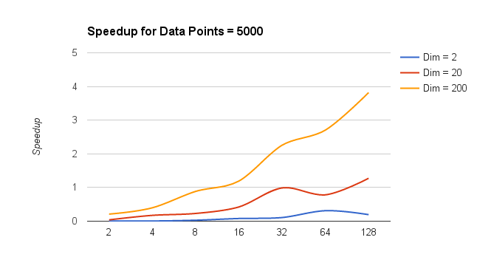

1. Runtime 50000 nodes:

|  |  |  |  |  |  |  |
| --- | --- | --- | --- | --- | --- | --- |
| Number of Clusters | CPU(Dim = 2) | GPU(Dim = 2) | CPU(Dim = 20) | GPU(Dim = 20) | CPU(Dim = 200) | GPU(Dim = 200) |
| 2 | 0.0598 | 1.6403 | 0.7285 | 1.7903 | 12.9893 | 8.0939 |
| 4 | 0.1245 | 1.3288 | 1.7506 | 1.9035 | 22.7088 | 7.1148 |
| 8 | 0.4512 | 1.3278 | 6.8116 | 2.284 | 53.0952 | 7.1728 |
| 16 | 1.302 | 1.3284 | 16.8019 | 2.3741 | 80.8285 | 8.4399 |
| 32 | 3.9175 | 1.33 | 29.4579 | 2.5649 | 106.8482 | 7.6028 |
| 64 | 10.9041 | 1.3309 | 48.7375 | 2.6366 | 176.9092 | 5.6719 |
| 128 | 12.7576 | 1.3307 | 66.7613 | 2.3066 | 183.6776 | 4.9939 |

Speedup:

|  |  |  |  |
| --- | --- | --- | --- |
| Number of Clusters | Dim = 2 | Dim = 20 | Dim = 200 |
| 2 | 0.03645674572 | 0.4441260745 | 1.604825857 |
| 4 | 0.0936935581 | 1.317429259 | 3.19176927 |
| 8 | 0.3398102124 | 5.129989456 | 7.402297569 |
| 16 | 0.9801264679 | 12.64822343 | 9.576949964 |
| 32 | 2.945488722 | 22.14879699 | 14.05379597 |
| 64 | 8.193027275 | 36.61995642 | 31.19046528 |
| 128 | 9.587134591 | 50.17006087 | 36.78039208 |

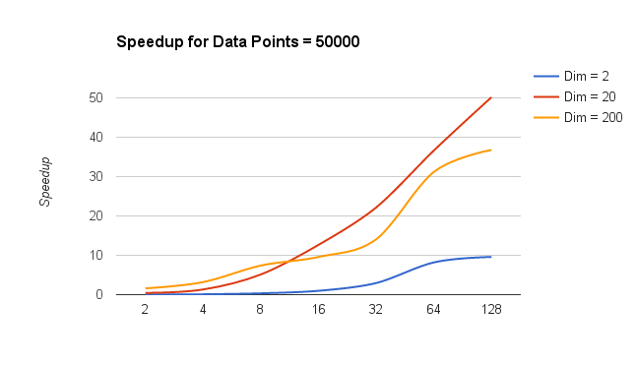

1. Runtime 100000 nodes:

|  |  |  |  |  |  |  |
| --- | --- | --- | --- | --- | --- | --- |
| Number of Clusters | CPU(Dim = 2) | GPU(Dim = 2) | CPU(Dim = 20) | GPU(Dim = 20) | CPU(Dim = 200) | GPU(Dim = 200) |
| 2 | 0.0716 | 1.6016 | 0.7287 | 2.0445 | 20.2902 | 10.5202 |
| 4 | 0.2316 | 1.3514 | 7.1117 | 2.6328 | 73.4858 | 19.0342 |
| 8 | 0.6 | 1.4177 | 17.2575 | 4.0122 | 143.5491 | 27.1399 |
| 16 | 3.4737 | 1.4875 | 32.227 | 4.1089 | 213.2782 | 20.8642 |
| 32 | 6.5977 | 1.6058 | 112.1626 | 3.7683 | 384.6378 | 17.2082 |
| 64 | 12.8961 | 1.5549 | 138.4984 | 4.8427 | 527.8646 | 12.9657 |
| 128 | 36.1652 | 1.6099 | 294.1505 | 6.3547 | 846.6653 | 14.6607 |

Speedup:

|  |  |  |  |
| --- | --- | --- | --- |
| Number of Clusters | Dim = 2 | Dim = 20 | Dim = 200 |
| 2 | 0.04470529471 | 0.3564196625 | 1.928689569 |
| 4 | 0.1713778304 | 2.701192647 | 3.86072438 |
| 8 | 0.4232207096 | 4.301256169 | 5.2892273 |
| 16 | 2.335260504 | 7.84321838 | 10.22220838 |
| 32 | 4.108668576 | 29.76477457 | 22.3520066 |
| 64 | 8.293845263 | 28.59941768 | 40.7123873 |
| 128 | 22.46425244 | 46.28865249 | 57.75067357 |

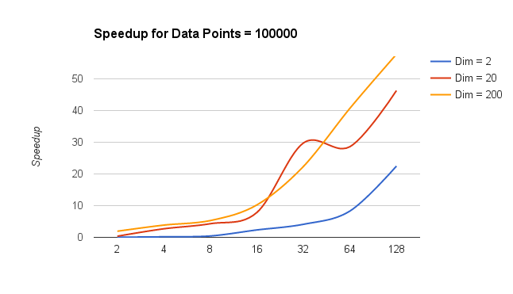

**OpenCL Results**

Now we repeat the same evaluations for OpenCL implementation. Vertices range from 5000, 50000, 100000 and dimensions change from 2, 20, 200.

The number of clusters vary from 2 to 128 with increasing power of 2.

1. Runtime: 5000 nodes

|  |  |  |  |  |  |  |
| --- | --- | --- | --- | --- | --- | --- |
| Number of Clusters | CPU(Dim = 2) | GPU(Dim = 2) | CPU(Dim = 20) | GPU(Dim = 20) | CPU(Dim = 200) | GPU(Dim = 200) |
| 2 | 0.0047 | 2.27 | 0.0656 | 2.26 | 0.451 | 2.24 |
| 4 | 0.0077 | 1.334 | 0.2416 | 1.352 | 0.6237 | 1.39 |
| 8 | 0.0381 | 1.333 | 0.3155 | 1.351 | 1.4002 | 1.413 |
| 16 | 0.1069 | 1.338 | 0.5893 | 1.358 | 1.8373 | 1.37 |
| 32 | 0.1439 | 1.335 | 1.3473 | 1.349 | 3.4217 | 1.391 |
| 64 | 0.4177 | 1.34 | 1.5733 | 1.358 | 4.2123 | 1.393 |
| 128 | 0.2607 | 1.345 | 1.7357 | 1.371 | 6.1313 | 1.426 |

Speedup

|  |  |  |  |
| --- | --- | --- | --- |
| Number of Clusters | Dim = 2 | Dim = 20 | Dim = 200 |
| 2 | 0.002070484581 | 0.02902654867 | 0.2013392857 |
| 4 | 0.005772113943 | 0.1786982249 | 0.448705036 |
| 8 | 0.02858214554 | 0.233530718 | 0.9909412597 |
| 16 | 0.07989536622 | 0.4339469809 | 1.341094891 |
| 32 | 0.1077902622 | 0.9987398073 | 2.459884975 |
| 64 | 0.3117164179 | 1.158541973 | 3.02390524 |
| 128 | 0.1938289963 | 1.266010212 | 4.299649369 |

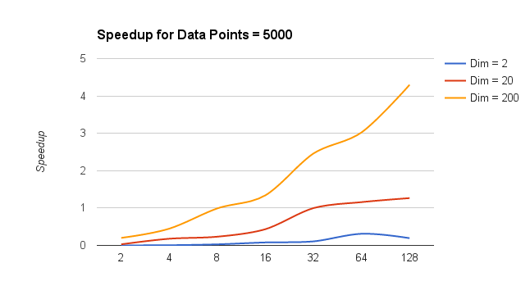

1. Runtime: 50000 nodes:

|  |  |  |  |  |  |  |
| --- | --- | --- | --- | --- | --- | --- |
| Number of Clusters | CPU(Dim = 2) | GPU(Dim = 2) | CPU(Dim = 20) | GPU(Dim = 20) | CPU(Dim = 200) | GPU(Dim = 200) |
| 2 | 0.0598 | 2.254 | 0.7285 | 2.329 | 12.9893 | 5.53 |
| 4 | 0.1245 | 1.342 | 1.7506 | 1.529 | 22.7088 | 5.59 |
| 8 | 0.4512 | 1.398 | 6.8116 | 2.284 | 53.0952 | 8.625 |
| 16 | 1.302 | 1.368 | 16.8019 | 2.054 | 80.8285 | 8.684 |
| 32 | 3.9175 | 1.408 | 29.4579 | 2.136 | 106.8482 | 8.995 |
| 64 | 10.9041 | 1.43 | 48.7375 | 2.288 | 176.9092 | 10.604 |
| 128 | 12.7576 | 1.4 | 66.7613 | 2.025 | 183.6776 | 10.517 |

Speedup

|  |  |  |  |
| --- | --- | --- | --- |
| Number of Clusters | Dim = 2 | Dim = 20 | Dim = 200 |
| 2 | 0.02653061224 | 0.3232031943 | 2.348878843 |
| 4 | 0.09277198212 | 1.304470939 | 4.062397138 |
| 8 | 0.3227467811 | 4.872389127 | 6.155965217 |
| 16 | 0.951754386 | 12.28209064 | 8.985936631 |
| 32 | 2.782315341 | 20.92180398 | 10.07621652 |
| 64 | 7.625244755 | 34.08216783 | 16.82126082 |
| 128 | 9.112571429 | 47.68664286 | 17.46482837 |

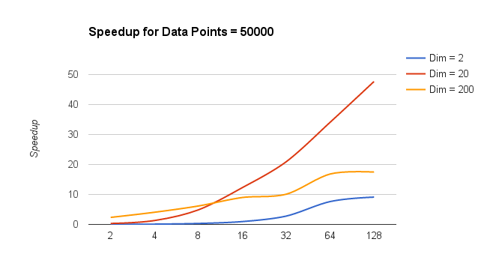

1. Runtime: 100000 nodes:

|  |  |  |  |  |  |  |
| --- | --- | --- | --- | --- | --- | --- |
| Number of Clusters | CPU(Dim = 2) | GPU(Dim = 2) | CPU(Dim = 20) | GPU(Dim = 20) | CPU(Dim = 200) | GPU(Dim = 200) |
| 2 | 0.0716 | 2.597 | 0.7287 | 2.698 | 20.2902 | 6.077 |
| 4 | 0.2316 | 1.359 | 7.1117 | 2.095 | 73.4858 | 12.261 |
| 8 | 0.6 | 1.383 | 17.2575 | 1.978 | 143.5491 | 13.605 |
| 16 | 3.4737 | 1.399 | 32.227 | 2.974 | 213.2782 | 10.26 |
| 32 | 6.5977 | 1.536 | 112.1626 | 3.481 | 384.6378 | 16.136 |
| 64 | 12.8961 | 1.474 | 138.4984 | 4.25 | 527.8646 | 18.093 |
| 128 | 36.1652 | 1.682 | 294.1505 | 5.217 | 846.6653 | 30.559 |

Speedup:

|  |  |  |  |
| --- | --- | --- | --- |
| Number of Clusters | Dim = 2 | Dim = 20 | Dim = 200 |
| 2 | 0.02757027339 | 0.2700889548 | 3.338851407 |
| 4 | 0.170419426 | 3.394606205 | 5.993458935 |
| 8 | 0.4338394794 | 8.724721941 | 10.55120176 |
| 16 | 2.482987848 | 10.83624748 | 20.78734893 |
| 32 | 4.295377604 | 32.22137317 | 23.83724591 |
| 64 | 8.749050204 | 32.58785882 | 29.17507323 |
| 128 | 21.50130797 | 56.38307456 | 27.70592297 |

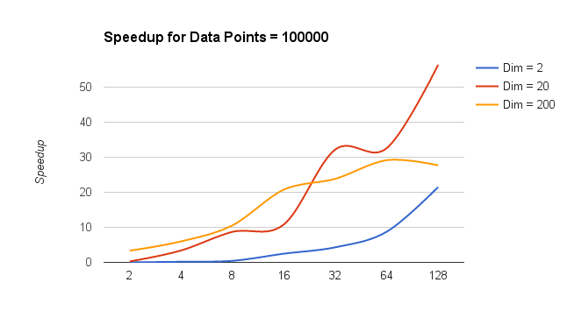

A brief description of the parallelization implementation is described below:

1. The main idea was to parallelize the labelling of the data objects into it's respective clusters, and the computation of delta needed to determine the convergence.

2. The data objects are passed from the host to the GPU once and the update of centroids is made between the CPU and device over each iteration.

3. The data is divided into chunks between the threads such that memory coalescing is maximized.

4. Data is arranged from [numObjs][coords] into [coords][numObjs], to provide memory coalescing, easy access and reduce bank conflicts.

1.